**ASSIGNMENT 9.2**

**PROBLEM STATEMENT :**

Twitter Data Stream with FLUME.

**PROCEDURE 1:**

Installed flume through the given method on ubuntu platform respectively.

flume.conf

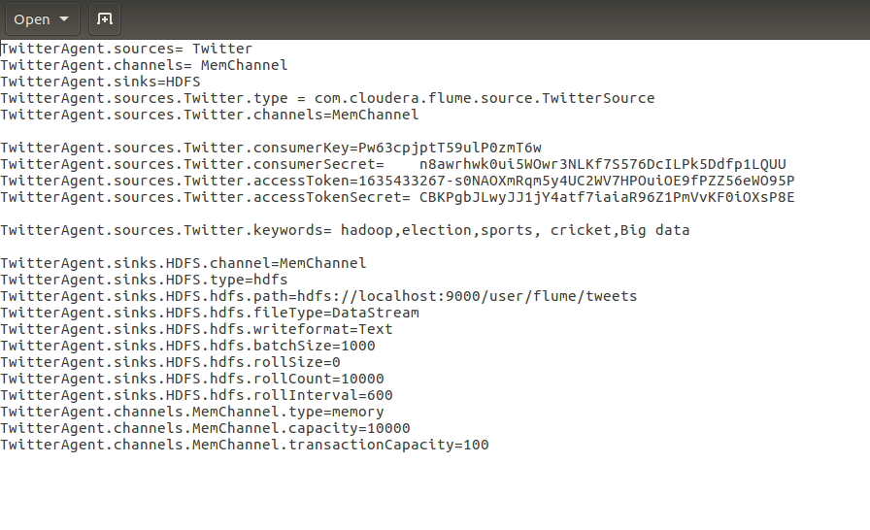

**PROCEDURE 2 :**

Process of creation of the twitter app.

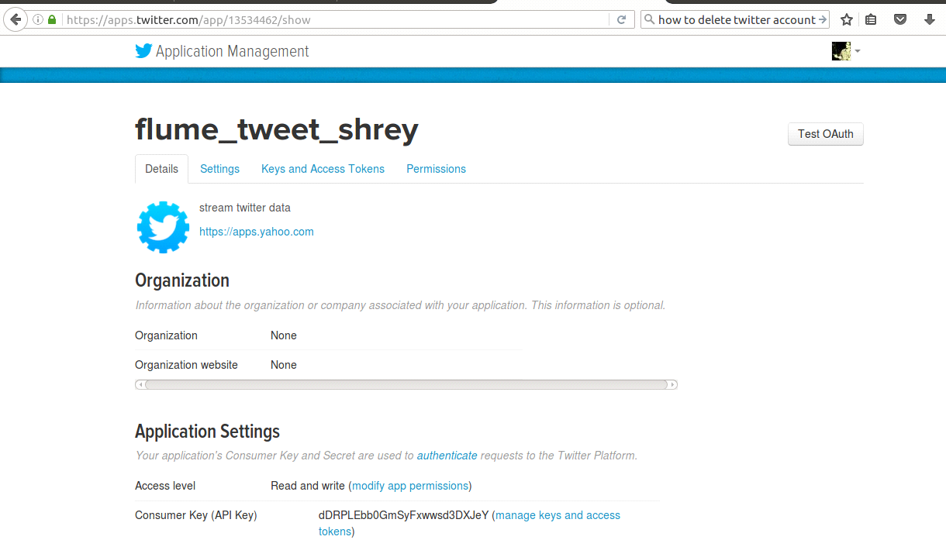

**PROCEDURE 3 :**

This involves the running of the flume agent :

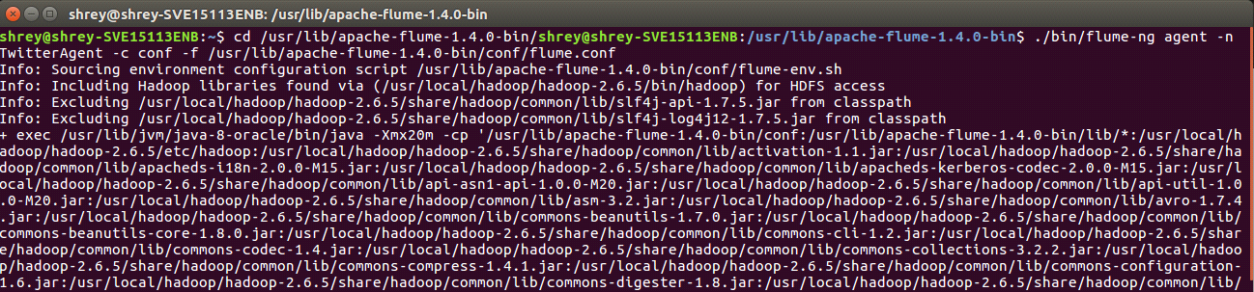

Checking on HDFS :

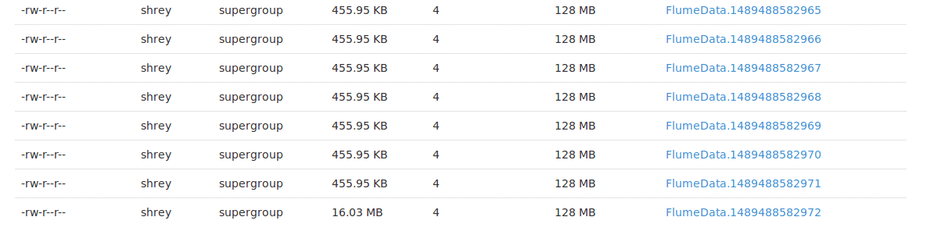

**PROCEDURE 4 :**

On opening the FlumeData file we can see that DATA STREAMING has started and the keeps on happening until and unless the the streaming is stopped (CTRL + C).

